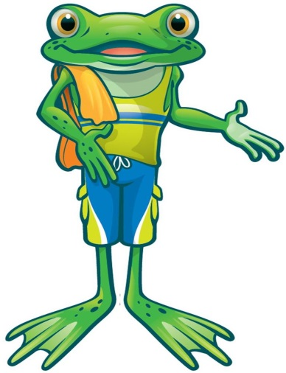
Rogers Aquatics Center
Junior Lifeguard Class Syllabus 2018
Prerequisites
- Swim 25 yards freestyle (front crawl) continuously
- Swim 25 yards breaststroke continuously.
- Tread water for 1 minute using arms and legs.
- Swim 25 yards backstroke or float unassisted on back for 30 seconds.
- Submerge and swim 10 feet under water.
- Must be between 11-14 years old and completed the 5th grade.
Junior Guards wear solid navy or red suits/trunks. **Cannot have Lifeguard or Guard printed on it.
Email Leanne Jacobson for Registration Information: ljacobson@rogersar.gov

Tues, April 3rd 5:30-8pm: (Waterpark) Sat, April 7th 12-4pm (Adult Wellness Center)
Orientation Prerequisite Swimming Skills
Team Building Shallow Water Assists
Causes/Prevention of Drowning Swimming with Rescue Tube
Recognize Someone Needing Help Improve Swimming Skills
Helping Someone in the Water Throwing Assists
Know What to Look For Approach Strokes
Know How to Look Entries into the Water
Know Where to Look Rescues at the Surface
Lifeguard Stations Surface Dives

Tues, April 10th 5:30-8pm (Waterpark) Sat, April 14th 12-4pm (Adult Wellness Center)
Surveillance Practice Review Shallow Water rescues
General Procedures for a Water Emergency Deep Water Rescues
Emergencies on Land Submerged Victim – Shallow Water
Performing a Primary Assessment Escapes
Making the 911 Call Two Person Removal from Water
Care for What You Find Putting it all Together
Emergency Action Plan Facility Safety Check
Incident Report
Swim Practice

Tues, April 17th 5:30-8pm (Waterpark) Sat, April 21st 10-2pm (Waterpark)
Lifeguard Rotations Breathing Emergencies – Primary Assessment
Conflict Resolution/FIND Model Giving Ventilations
Educating Others Conscious Choking
Life Jackets Unconscious Choking
Serving the Customer CPR/AED
Listening First Aid – Secondary Assessment
Handling Difficult Customers Heat Related Illness
Positive Feedback

Tues, April 24th 5:30-8pm (Waterpark) Sat, April 28th 12-4pm (Adult Wellness Center)
First Aid – Bleeding Head, Neck & Back Injury
Muscle, Bone & Joint Injury Head Splint
Common 1st Aid Injuries Shallow Water Back Boarding
Burns Removal from Water
Bee Stings Review
Finger Injury Written Test

